

**Spotting Fake News, AI Images & Bot-Generated Text**

**Spotting Fake News**

**1. Check the Source**

* Is the website reputable? (e.g., established news organizations)
* Look for an “About” page to verify credibility.
* Be wary of sources with a history of spreading misinformation.

**2. Examine the Headline**

* Does it use sensational or emotionally charged language?
* If it sounds too outrageous or unbelievable, verify with other sources.

**3. Verify the Author**

* Is the author a credible journalist or expert?
* Check their background and previous work.

**4. Cross-Check the Information**

* Are other reliable news sources reporting the same story?
* If only one source is covering it, be skeptical.

**5. Look for Supporting Evidence**

* Does the article cite credible sources?
* Be cautious if it lacks references or cites questionable sources.

**6. Watch for Bias**

* Does the article present only one side of an issue?
* Be mindful of confirmation bias—does it simply reinforce your beliefs?

**7. Inspect the Date**

* Old news can be misrepresented as current events.
* Ensure the context is still relevant.

**8. Check the URL**

* Fake news sites may use URLs that mimic real news sites (e.g., “.co” instead of “.com”).

**9. Assess the Media (Images & Videos)**

* Reverse search images to see if they’ve been used out of context.
* Watch for digitally altered visuals.

**10. Fact-Check**

* Use fact-checking websites like Snopes, FactCheck.org, or PolitiFact.
* If in doubt, wait before sharing.

**Spotting AI-Generated Images**

**1. Look at the Details**

* AI images may have overly smooth textures or unrealistic lighting.
* Check for distortions in fingers, eyes, and reflections.

**2. Inspect the Background**

* AI-generated backgrounds may contain strange artifacts or blurry, nonsensical details.

**3. Analyze Text and Logos**

* AI struggles to generate clear, readable text—letters often look warped or gibberish.

**4. Use Reverse Image Search**

* Tools like Google Reverse Image Search or TinEye can help verify if an image is AI-generated or manipulated.

**5. Check for Overly Perfect or Odd Features**

* AI images may have inconsistent facial symmetry or extra limbs.

**6. Use AI-Detection Tools**

* Websites like AI or deepfake detectors can help verify authenticity.

**Spotting Bot-Generated Text**

**1. Check for Repetitive or Generic Language**

* AI-generated text may overuse certain phrases or have an unnatural flow.
* Look for vague, overly broad statements that lack nuance.

**2. Look for a Lack of Personal Experience or Emotion**

* AI tends to produce text that is factual but lacks personal insights or storytelling elements.

**3. Analyze the Sentence Structure**

* Many AI-generated texts follow a uniform structure without much variation in sentence length or style.

**4. Verify Facts and Sources**

* AI can generate false or misleading information—double-check key facts against trusted sources.

**5. Test for Inconsistencies**

* AI-generated content might contradict itself within the same passage or present conflicting details.

**6. Use AI-Detection Tools**

* Various online tools can help determine whether text was generated by AI.

**Be a responsible media consumer—verify before believing and sharing!**

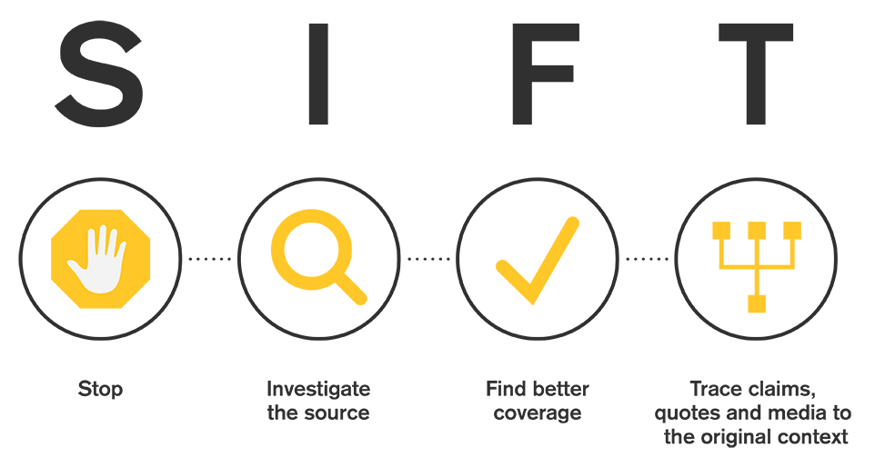

**S - Stop**

**Before you read or share an article or video, STOP!​**

Be aware of your emotional response to the headline or information in the article. Headlines are often meant to get clicks, and will do so by causing the reader to have a strong emotional response.

Before sharing, consider:

* What you already know about the topic. ​
* What you know about the source. Do you know its reputation?

Before moving forward or sharing, use the other three moves: **I**nvestigate the Source, **F**ind Better Coverage, and **T**race Claims, Quotes, and Media back to the Original Context.

**I - Investigate the Source**

**The next step before sharing is to Investigate the Source.**

Take a moment to look up the author and source publishing the information.

* What can you find about the author/website creators? ​
* What is their mission? Do they have vested interests? ​Would their assessment be biased?
* Do they have authority in the area?​

Use lateral reading. Go beyond the 'About Us' section on the organization's website and see what other, trusted sources say about the source.​ You can use Google or Wikipedia to investigate the source.

**F - Find Better Coverage**

**The next step is to Find Better Coverage or other sources that may or may not support the original claim.**

Again, use lateral reading to see if you can find other sources corroborating the same information or disputing it.​

* What coverage is available on the topic?
* Keep track of trusted news sources.

Many times, fact checkers have already looked into the claims. These fact-checkers are often nonpartisan, nonprofit websites that try to increase public knowledge and understanding by fact checking claims to see if they are based on fact or if they are biased/not supported by evidence.

* [FactCheck.org​](https://www.factcheck.org/)
* [Snopes.com​](https://www.snopes.com/)
* Washington Post Fact Checker​
* PolitiFact

**T - Trace Claims, Quotes, and Media to their Original Context**

**The final step is to Trace Claims, Quotes, and Media to their Original Context.**

When an article references a quote from an expert, or results of a research study, it is good practice to attempt to locate the original source of the information.​ Click through the links to follow the claims to the original source of information. Open up the original reporting sources listed in a bibliography if present

* Was the claim, quote, or media fairly represented?
* Does the extracted information support the original claims in the research? ​
* Is information being cherry-picked to support an agenda or a bias?​
* Is information being taken out of context?​

Remember, headlines, blog posts, or tweets may sensationalize facts to get more attention or clicks. ​Re-reporting may omit, misinterpret, or select certain facts to support biased claims. If the claim is taken from a source who took it from another source, important facts and contextual information can be left out. Make sure to read the claims in the original context in which they were presented.

<https://guides.lib.uchicago.edu/c.php?g=1241077&p=9082322>

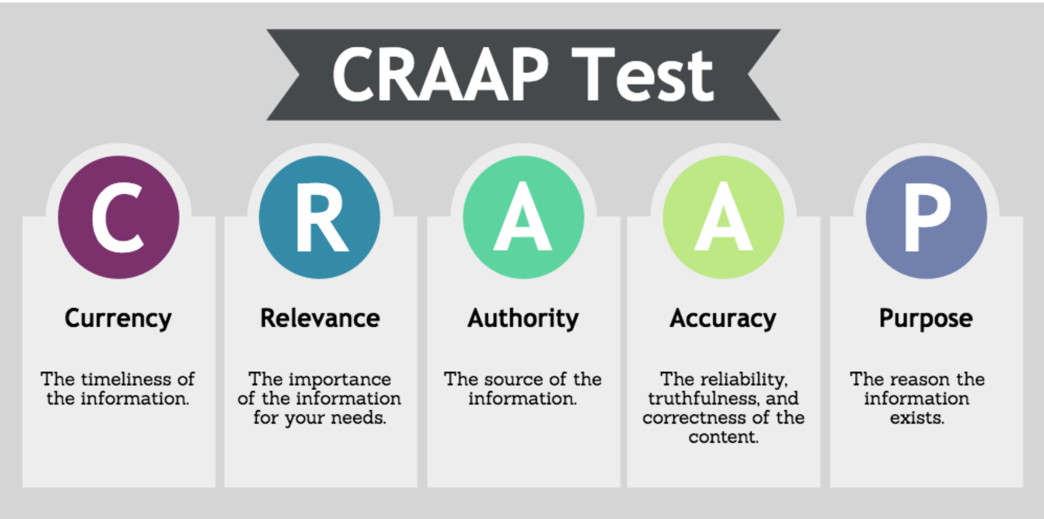

**C - Currency**

**The timeliness of the information:**

When was the information published or posted?  
Has the information been revised or updated?  
Does your topic require current information, or will older sources work as well?  
Are the links functional?

**R - Relevance**

**The importance of the information for your needs:**

Does the information relate to your topic or answer your question?  
Who is the intended audience?  
Is the information at an appropriate level (i.e. not too elementary or advanced for your needs)?  
Have you looked at a variety of sources before determining this is one you will use?  
Would you be comfortable citing this source in your research paper?

**A - Authority**

**The source of the information:**

Who is the author/publisher/source/sponsor?  
What are the author's credentials or organizational affiliations?  
Is the author qualified to write on the topic?  
Is there contact information, such as a publisher or email address?  
Does the URL reveal anything about the author or source?

.com = Commercial sites  
.edu = Educational institutions  
.gov = Government.org = Non-profit organizations  
.mil = Military  
.net = Network.

**A - Accuracy**

**The reliability, truthfulness, and correctness of the content:**

Where does the information come from?  
Is the information supported by evidence?  
Has the information been reviewed or refereed?  
Can you verify any of the information in another source or from personal knowledge?  
Does the language or tone seem unbiased and free of emotion?  
Are there spelling, grammar or typographical errors?

**P - Purpose**

**The reason the information exists:**

What is the purpose of the information? Is it to inform, teach, sell, entertain or persuade?  
Do the authors/sponsors make their intentions or purpose clear?  
Is the information fact, opinion or propaganda?  
Does the point of view appear objective and impartial?  
Are there political, ideological, cultural, religious, institutional or personal biases?

<https://library.csuchico.edu/sites/default/files/craap-test.pdf>